Ayyoub Malek; M.D
https://scholar.google.com/citations?user=hxf9KHYAAAAJ&hl=fa

Ali fakhari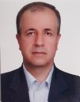
https://scholar.google.com/citations?user=5xGGVBsAAAAJ&hl=fa

Fatemeh Ranjbar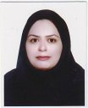
https://scholar.google.com/citations?user=NSfyog4AAAAJ&hl=fa

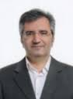
Alireza Farnam
https://scholar.google.com/citations?user=ZJfUvwgAAAAJ&hl=en

Mostafa Farahbakhsh
https://scholar.google.com/citations?user=CMTdOlMAAAAJ&hl=fa

Shahrokh Amiri 
https://scholar.google.com/citations?user=9ko0wNUAAAAJ&hl=fa

Sara Farhang
https://scholar.google.com/citations?user=Gzh7MzUAAAAJ&hl=fa

Ali Reza Shafiee-Kandjani
https://scholar.google.com/citations?user=AEvC1yYAAAAJ&hl=fa
Sepideh Herizchi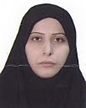
https://scholar.google.com/citations?user=vWeGjbAAAAAJ&hl=fa
Arash Mohagheghi
https://scholar.google.com/citations?user=T0T41GkAAAAJ&hl=fa

Seyed Gholamreza Noorazar
https://scholar.google.com/citations?user=PKciT30AAAAJ&hl=fa

Reza Naghdi Sadeh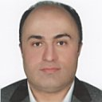
https://scholar.google.com/citations?user=u5rVRPgAAAAJ&hl=fa

sanaz norouzi
https://scholar.google.com/citations?user=K7LP4qwAAAAJ&hl=fa
Hassan Shahrokhi
https://scholar.google.com/citations?user=_R9w8VsAAAAJ&hl=fa

Zahra Mousavi
https://www.researchgate.net/profile/Zahra-Mousavi-17

https://www.researchgate.net/profile/Zahra-Mousavi-17
Saeedeh Majidi Zolbanin
https://scholar.google.com/citations?hl=fa&user=3vOHk6gAAAAJ

