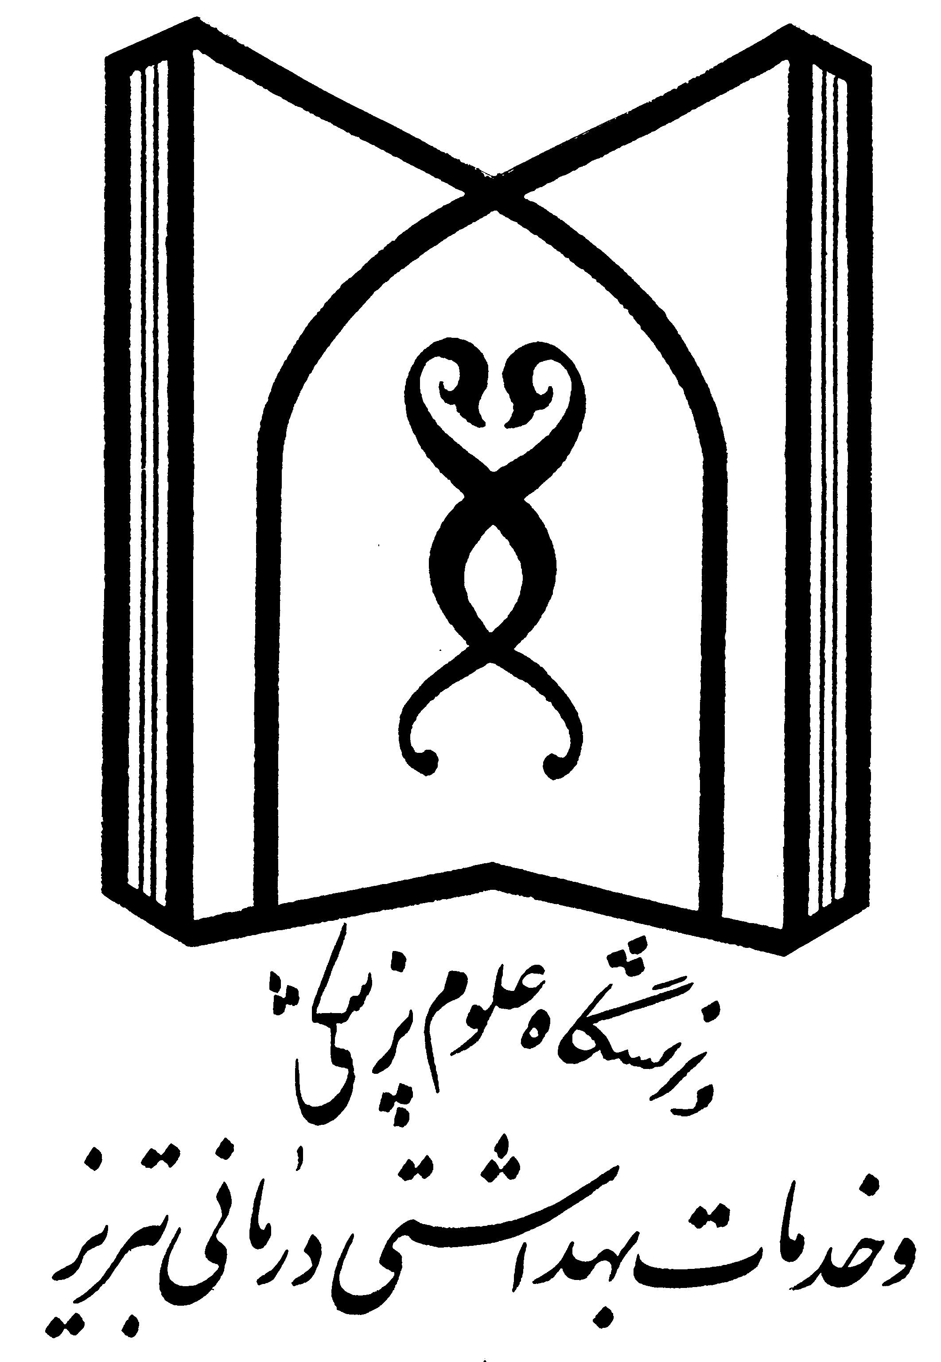

Tabriz University of Medical Sciences

Faculty of Medicine

A thesis submitted for MD degree

Study and Comparing the Patients with
Renal Failure and Ischemic Heart Disease

Mohammad J. Farajzadeh

Supervisor:
Rezvaniyeh Salehi M.D.

Advisors:
Zahra Pourkashi
Hossein Fathi M.D.

Sep 2004

Thesis No: 81/1-225/157

